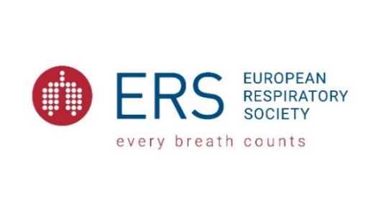

Late Breaking: WHO 2021 Air Quality Guidelines

Wednesday 22nd September 17:00 – 18:00 CET

Chaired by Zorana J. Andersen, Chair of the ERS Environment and Health Committee

17:00-17:05 | Welcome and introduction  Zorana J. Andersen, Chair of the ERS Environment and Health Committee
17:05-17:20 | WHO 2021 Air Quality Guidelines  Maria Neira, World Health Organisation (WHO), Geneva, Switzerland
17:20-17:33 | From Evidence to Guidelines – how the evidence from the systematic reviews was translated into the guidelines?  Bert Brunekreef, Institute for Risk Assessment Sciences, Utrecht University, Utrecht, the Netherlands
17:33-15.45 | From Guidelines to Public Health  Annette Peters, German Research Center for Environmental Health, Munich, Germany
17:45-17:55 | Q & A
17:55-18:00 | Closing  Zorana J. Andersen, Chair of the ERS Environment and Health Committee

