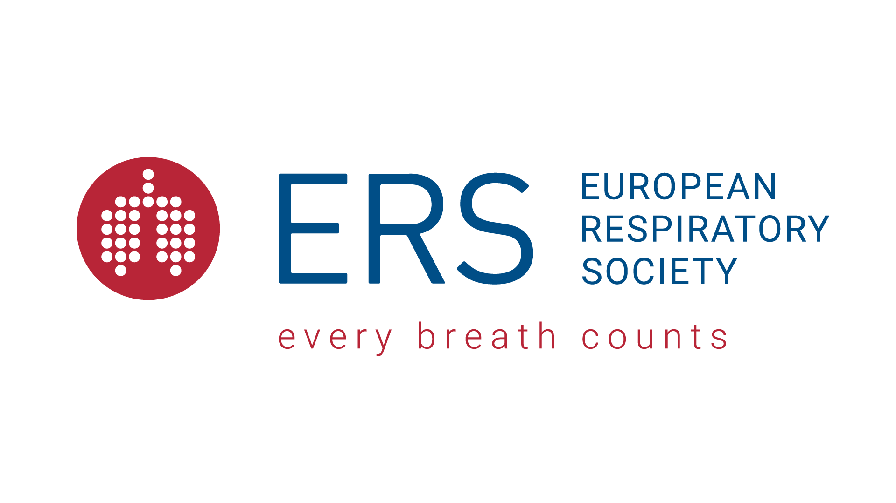

ERS Headquarters, 4 Avenue Ste-Luce, CH-1003 Lausanne, Switzerland
Tel +41 21 213 01 01 Email fellowships@ersnet.org

ERS Clinical Training Fellowship
END OF TRAINING QUESTIONNAIRE & REPORT
Comments from the Host Supervisor

Name of the Host Supervisor:

Name of the supervised fellow:
(Please note that these comments are confidential and will not be communicated to the fellow in question. Please complete and return by e-mail to fellowships@ersnet.org)

Has the fellow fully implemented the work plan? Yes  No  (explain)
……………………………………………………………………………………………………………..
……………………………………………………………………………………………………………..
……………………………………………………………………………………………………………..

Was the stay of the fellow Too short?  Too long?  Sufficient?  (explain)
……………………………………………………………………………………………………………..
……………………………………………………………………………………………………………..
……………………………………………………………………………………………………………..

a) Where appropriate, rate the following regarding the fellow:
(use a scale of 5 – Excellent; 4 – Very Good; 3 – Good; 2 – Average; 1 – Poor)

Integration into the work group | 5 | 4 | 3 | 2 | 1
Working attitude | 5 | 4 | 3 | 2 | 1
Interest in learning | 5 | 4 | 3 | 2 | 1
Capacity to train others | 5 | 4 | 3 | 2 | 1

b) Other Comments

……………………………………………………………………………………………………………..
……………………………………………………………………………………………………………..
……………………………………………………………………………………………………………..
- Please rate your overall degree of satisfaction with the fellowship programme?
(use a scale of 5 – Excellent; 4 – Very Good; 3 – Good; 2 – Average; 1 – Poor)
…………………………………………………………………………………………………………………..
…………………………………………………………………………………………………………………..

Would you be willing to supervise a similar Fellowship? Yes  No  (if not, why not?)
……………………………………………………………………………………………………………..
……………………………………………………………………………………………………………..
- Could you suggest improvements and advice for future fellowships?
……………………………………………………………………………………………………………..…………………………………………………………………………………………………………..………………………………………………………………………………………………………………………………..

